

Instructions for authors and further details:

http://ijheld.lakeheadu.ca

“I Can Climb the Tree!” Exploring Young Children’s Play and Physical Activity in a Forest School Program

Debra Harwood¹, Susan Reichheld¹, Sinead McElhone², & Brandon J. McKinlay¹

- Brock University
- Niagara Region

Published online: November 1, 2017

Edition period: Volume 4, 2017

____________________________________________________________

To cite this article: Harwood, D., Reichheld, S., McElhone, S., & McKinlay, B. J. (2017). “I can climb the tree!” Exploring young children’s play and physical activity in a forest school program. The International Journal of Holistic Early Learning and Development, 4, 45-62.
____________________________________________________________

PLEASE SCROLL DOWN FOR ARTICLE

The International Journal of Holistic Early Learning and Development Vol. 4 2017 45
______________________________________________________________________________

“I Can Climb the Tree!” Exploring Young Children’s Play and Physical Activity in a Forest School Program

Debra Harwood Susan Reichheld
Brock University Brock University

Sinead McElhone Brandon J. McKinlay
Niagara Region Brock University

Abstract
_____________________________________________________________________________

Qualitative and quantitative measures of 3- and 4-year-old children’s play and physical activities in a forest program in Ontario, Canada were conducted over a school year. Theoretically, Gibson’s (1979) concept of affordances and Nicholson’s (1971) concept of loose parts were utilized to explore the role of the forest (natural) environment as a catalyst for physically active play. The study demonstrated that levels of physically active play in the forest were twice that of a ‘typical’ day in a childcare center and specific characteristics of the forest play area did afford unique opportunities for more vigorous types of play. Implications for promoting physical activity among young children within childcare programs are discussed.
______________________________________________________________________________

46 Harwood et al. – Exploring Young Children’s Play
______________________________________________________________________________

Physical activity is uniformly recognized as “necessary for healthy growth and development of children” (Vanderloo, Tucker, Johnson, & Holmes, 2013, p. 1173). Physical activity in children has been associated with numerous health benefits, such as improvements in muscular strength and endurance, improved respiratory fitness, and enhanced motor skill, coordination and competency, while reducing levels of depression and anxiety (Behm, Faigenbaum, Falk, & Klentrou, 2008). These benefits are typically achieved when physical activity is supplemented daily, accruing at least 60 minutes of moderate intensity exercise; however, it should be noted that the greatest benefits are provided by a greater duration or a more vigorous intensity (Janssen & Le Blanc, 2010; World Health Organization, 2010).
Despite the positive benefits associated with physical activity participation, a large portion of children remain physically inactive. Furthermore, physical inactivity has been credited as “one of the most important public health problems of the 21st century” (Blair, 2009, p. 1). In Canada, a common assumption is that young children, by the very nature of their age and experiences, are active. Nonetheless, poor rates of physical activity for children are alarming (Statistics Canada, 2015), earning Canada a low score on the most recent ParticipACTION report card (Barnes et al., 2016).
A wide range of benefits of play in natural spaces has been noted by previous researchers (Lucas, 2015; O’Brien & Murray, 2007). For children, large outdoor spaces naturally invite running, jumping, rough-and-tumble types of play, and movement that is generally not encouraged in a more structured setting. This type of rambunctious play has positive developmental benefits such as increased agility, stamina, motor coordination, spatial-kinesthetic awareness, and bone/muscle development (Bee & Boyd, 2011; Goodard Blythe, 2004). Expectantly, more vigorous physical activity generally occurs outdoors in childcare settings (Vanderloo et al., 2013). Yet despite these physical and developmental related benefits, Canadian preschool children are inactive (Stone, Faulkner, & Buliung, 2013).
Presently within Canada, little understanding exists of the relationship between the nature and type of outdoor environments, the type of play engaged in, and physical activity levels. The Canadian context may contribute uniquely to children’s physical activity levels given the climate, fewer hours of sunlight in winter, and the greater likelihood of young children playing indoors during winter or inclement weather. Certainly, educators themselves have reported the Canadian weather as a barrier to taking children outdoors (Munroe & MacLellan-Mansell, 2013).
The aim of the current study was to examine environmental and play factors associated with children’s moderate- to vigorous-intensity physical activity (MVPA) during their ‘typical’ daycare program and alternatively while attending a forest school program. The forest school model under consideration in this research immersed the children and their educators two mornings each week in a natural (uncultivated) woodland space, where the play and learning were largely child-initiated, emergent, and play-based (MacEachren, 2013).

Physical (In)Activity

Rates of physical activity among Canadian children are quite low. For children aged 5-17 years, the Canadian guidelines are clear with a minimum of 60 minutes of MVPA recommended each day (Stone et al., 2013). Yet MVPA levels are shockingly low for this age group as only 9% meet the recommended minimum (Statistics Canada, 2015). The recommendations for younger children indicate a need for 180 accumulated minutes throughout the day of physical activity at any intensity level for toddlers (1-2 years) and preschoolers (aged 3-4 years) (Canadian Society for Exercise Physiology, 2012). Although Statistics Canada (2015) indicates that children in the
The International Journal of Holistic Early Learning and Development Vol. 4 2017 47
______________________________________________________________________________

3- to 4-year-old group are doing well with 70% achieving the recommended 180 minutes of physical activity (at any level), concerns are being raised regarding physical inactivity of Canada’s youngest age group, particularly while attending childcare programs (Reilly, 2010; Temple, Naylor, Rhodes, & Higgins, 2009; Vanderloo et al., 2013). Given that the majority (54%) of Canadian parents with children under the age of 4 use childcare, most often on a regular and full-time basis (i.e., at least 30 hours per week) (Sinha, 2015), opportunities to engage in physical activity while attending childcare are significant.
Many young children spend long hours in childcare settings, so physical activity guidelines are an important consideration. Despite the somewhat promising Statistics Canada (2015) results of physical activity of 3- to 4-year-olds, overall, Canada rated a score of D- related to physical activity of children and youth on the most recent ParticipACTION report card (Barnes et al., 2016). Moreover, the Statistics Canada data did not differentiate between children attending a childcare center and those who did not attend a program, while there is strong evidence suggesting that the majority of childcare programs are contributing to inactivity levels in young children (Brown et al., 2009; Kuzik, Clark, Ogden, Harber, & Carson, 2015; Pate, Pfeiffer, Trost, Ziegler, & Dowda, 2004; Temple et al., 2009; Tucker, 2008; Vanderloo et al., 2013). Notably, the largest review conducted thus far, examining 39 studies of children across seven countries (United States, Scotland, Finland, Australia, Chile, Estonia, and Belgium) found that only 54% of preschool age children engaged in a minimum of 60 minutes of daily activity (Tucker, 2008).
Previous accelerometry research of young children’s activity levels has also found low levels of MVPA; specifically, only 2% of monitored hours at age 3, and 4% at age 5 were noted in a study of U.K. children (Reilly et al., 2004). In the U.S., Pate et al.’s (2004) accelerometer study found that among 281 preschoolers examined, children on average engaged in 7.7 minutes of MVPA per hour while attending their respective programs. Additionally, some observational research in the U.S. has also highlighted a concern for the low rate of MVPA (less than 3% of observations) and high rates of sedentary behavior (80% of observations) noted in young children’s preschool experiences (Pate, McIver, Dowda, Brown, & Addy, 2008).
There are fewer comparable large-scale studies available on Canadian preschool age children and the findings that do exist appear somewhat mixed. One Canadian study that examined toddler and preschool children’s activity levels found high levels of sedentary behavior (Kuzik et al., 2015). The 114 participating children aged 19-60 months from eight childcare centers throughout the province of Alberta wore accelerometers for five consecutive days during the fall season. Kuzik and colleagues (2015) observed that children were sedentary 60% of the time and engaged in light activities 30.6% while only engaging in MVPA 7%. And although preschool age children were less sedentary and more active compared to toddlers, most of the physical activity was light and not moderate to vigorous. Importantly, the study provides significant insights into toddlers’ and preschool children’s physical activities from diverse cities across Alberta. However, the data was captured all within one season and environmental conditions were not assessed. Additionally, it is unclear how much time the children spent indoors versus outdoors.
Conversely, the 30 Ontario preschoolers participating in a study by Obeid, Nguyen, Gabel, and Timmons (2011), were found to achieve the recommended physical activity levels with the majority completing 220 minutes of daily physical activity, 75 minutes of which was MVPA. Notably, Obeid and colleagues (2011) measured children’s activity levels throughout an entire day and children were not attending childcare programs. The time of year and percentage of outdoor versus indoor measurement were not specified.

48 Harwood et al. – Exploring Young Children’s Play
______________________________________________________________________________

Alternatively, two separate smaller scale studies (Temple et al., 2009; Vanderloo et al., 2013) found preschool children woefully inactive during their hours of attendance within both home-based childcare and center-based programs. Within home-based childcare in British Columbia, Temple and colleagues (2009) found that children achieved 12.7 minutes of MVPA during childcare hours in the summer months, whereas Vanderloo and colleagues (2013) noted 11.45 minutes of MVPA and 132.61 minutes of total activity per day during childcare hours in October and November. The 31 Ontario preschoolers attending childcare in the accelerometer study by Vanderloo et al. (2013) experienced greater MVPA and total physical activity (TPA) levels outdoors compared to indoors, with boys demonstrating a statistically significant increase in MVPA outdoors. Vanderloo and colleagues’ findings again highlight the importance of context, specifically the potential positive impact and role of the outdoors in promoting higher levels of physical activity. In a subsequent study, Vanderloo and Tucker (2015) reported that activity levels within childcare varied based on the day of the week, with children’s physical activity gradually increasing to peak mid-week before deescalating towards the end of the week.
Researchers such as Tucker et al. (2016) highlight the importance of examining activity levels while children attend childcare programs. Moreover, contexts (e.g., home childcare or center-based program, time of day, educator training, season, and weather) should be examined and considered within research. Factors such as indoor/outdoor environments (Soini et al., 2014; Vanderloo et al., 2013), the type and availability of play equipment (Kwon, Mason, & Becker, 2015), educator training and dedicated physical activity sessions (Kwon et al., 2015; Van Zandvoort, Tucker, Irwin, & Burke, 2010), and seasonal variations (Soini et al., 2014) have also demonstrated an impact on children’s activity levels.
Of interest to this study, prior research clearly suggests that the outdoors in general provokes more physicality among children than indoor settings (Gray et al., 2015; Pate et al., 2004; Soini et al., 2014; Vanderloo et al., 2013). Hence, multiple measures of children’s physical activity across a range of outdoor contexts and seasons could yield a more holistic understanding of children’s movement levels within Canadian early childhood programs. To date, little research exists that examines children’s activity levels in a natural (forest) outdoor setting, across three seasons (fall, winter, spring), and that combines both naturalistic observational methods and accelerometry measures. Consequently, as part of a larger mixed-methods study and to specifically address this gap in the literature, this article outlines findings related to children’s physical activity levels within a forest environment in Ontario, Canada and the types of play that contributed to their vigorous movements. The research findings offer several insights for promoting physical activity among young children – a priority for many parents, educators, and community agencies. In this study, we addressed the research question, what are the ways in which a natural outdoor environment (forest school program) might uniquely contribute to children’s vigorous physical activity?

Nature as a Potential Context for Promoting Active Children

Fjørtoft’s (2004) definition of a natural environment as one that is “not designed or cultivated by humans” (p. 24) aptly describes the context where this study was undertaken. The children and educators participated in a forest school program two mornings each week, year-round. Forest school program models vary but generally involve an immersion of children in a natural context to learn, play, and develop (Child & Nature Alliance of Canada, 2017). Here, we define the study’s forest school program as adhering to two specific principles: 1) regular and repeated access to the same natural space; and 2) adopting emergent, experiential, and place-based
The International Journal of Holistic Early Learning and Development Vol. 4 2017 49
______________________________________________________________________________

learning philosophies (MacEachren, 2013). The environment itself was natural, located alongside a public trail through the woods, but a ‘wild’ space nonetheless (Figure 1). Specifically, we queried whether aspects of the natural environment invited and provoked certain types and experiences of physical activity.

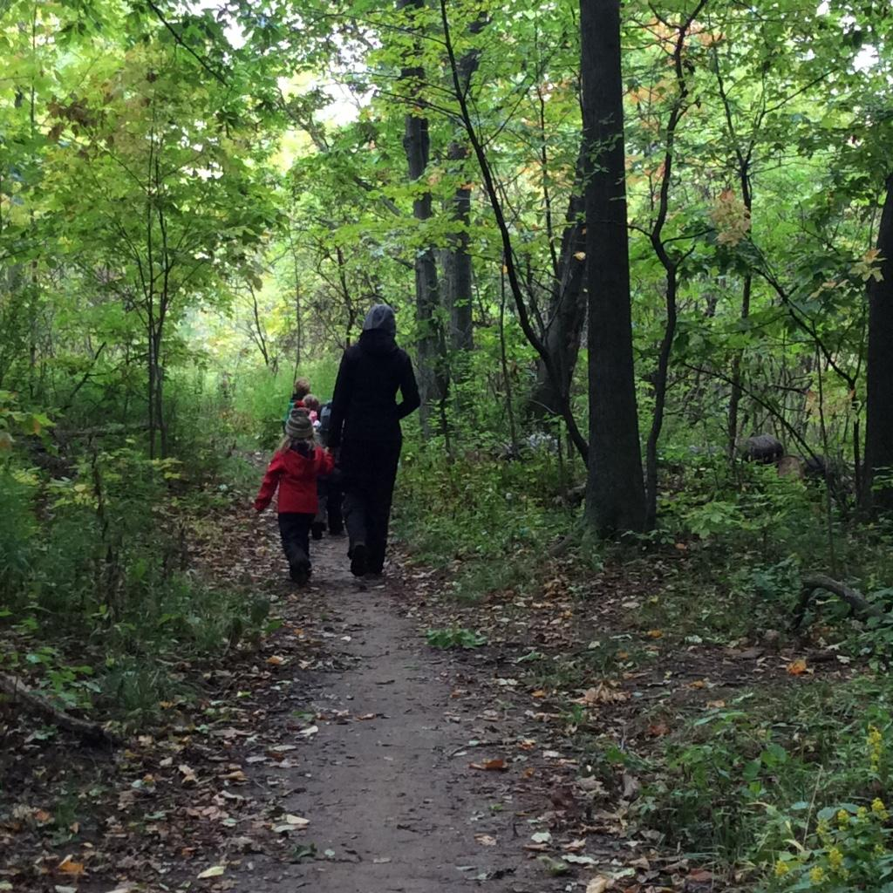

Figure 1. Natural outdoor environment of the forest school program

Gibson’s (1979) theory of affordances and Nicholson’s (1971) concept of loose parts helped to inform our examination of the potential role of the natural environment in fostering play and physical activity. Loosely interpreted, affordances within the natural environment offer, provoke, and furnish opportunities for the child to act (Gibson, 1979). Affordances are individually interpreted between the child and the environment, thus “include the properties from both the environment and the acting individual” (Kyttä, 2002, p. 109). Kyttä (2004) refers to both the potential affordances (inherent opportunities within a space) and realized affordances (opportunities the children make use of) as important variables, with potential affordances dependent upon a child’s physical skills, body proportions, and social and personal intentions and realized affordances a factor of the independent mobility of the child (Kyttä, 2004). Loose parts are also an important consideration when examining an environment. Nicholson (1971) deemed within “any environment, both the degree of inventiveness and creativity, and the possibility of discovery, are directly proportional to the number and kind of variables within it” (p. 30). Thus, within any environment regarded as appropriate and stimulating for children, one should examine the affordances for physical activity (e.g., trees to climb) and the specific loose
50 Harwood et al. – Exploring Young Children’s Play
______________________________________________________________________________

parts that may offer multiple invitations for activity (e.g., rocks and tree branches for carrying), and the ways in which those affordances and loose parts are interpreted and actualized by the individual child.
In general, children tend to demonstrate a preference for the outdoors (Norðdahl & Einarsdóttir, 2015) and favor natural outdoor environments over those that are constructed or fabricated. While outdoors, children enjoy active and risky play (Clark, 2007; Fjørtoft & Sageie, 2000), and desire challenge and varied opportunities within their outdoor spaces. Thus, natural environments appear to act as a catalyst for play (Bjørgen, 2016) where the complexity and diversity inherent with nature offer increased opportunities for play and activities (Fjørtoft & Sageie, 2000).
In Norðdahl and Einarsdóttir’s (2015) research with children in Iceland, 4- and 5-year-old children indicated a preference for outdoor environments. Specifically, the interviewed children cited a desire for diverse opportunities for different types of play in the outdoors, physically challenging play that was still safe, the ability to explore, and opportunities to connect with others in the outdoors. The children also shared a preference for being able to construct ‘secret places’ and the importance of the aesthetics (e.g., beautiful things and varied colors). Despite these preferences, little is known about the relationship between outdoor play and physical activity and the affordances a natural environment might offer.
The relationship between affordances for play and physical activity was measured in preschool age children in a Norwegian study by Storli and Hagen (2010). Sixteen 3- to 5-year-old children participated, wearing accelerometers during outdoor activities on the playground in winter and spring and in nature in spring. The intensity of children’s physically active play did not significantly differ between the environments; however, individual differences among the children were found with physically energetic children consistently active across all days and contexts. Conversely, less active children on the traditional playground were even less active in the natural environment. Importantly, the children were observed and recorded the entire time outdoors either in the playground or the natural environment. Both environments offered very similar affordances. Additionally, the researchers observed, “the day in nature was the day where the adult organisation was most apparent and the day the physical activity in the group was most homogenous” (Storli & Hagen, 2010, p. 455). Thus, the adult’s role is another important consideration.
Children’s moderate to vigorous physical activity levels did appear to benefit from forest school programs in the studies of Austin, Knowles, and Sayers (2013) and Lovell (2009). Lovell’s (2009) dissertation study in Scotland examined 26 school age children’s physical activity levels in a forest school in comparison to their typical school days. Accelerometer measures were used over three types of school day: forest school day, ordinary school day (with no timetabled physical activity), and active school day (with a scheduled physical education lesson). The children were found to be twice as active during forest school days than on their most active school days. Additionally, children exceeded the daily hour of recommended MVPA on forest school days, whereas only 29.1 and 20.5 minutes of MVPA were achieved on active school and inactive school days, respectively (Lovell, 2009).
Austin and colleagues (2013) assessed 59 primary age children’s physical activity levels during 12 weekly forest school sessions. Accelerometer measures were undertaken for 7 consecutive days and included data from forest school sessions, a regular school day, a school day including a physical education lesson, and weekend days. Overall, children were found to be more active on the forest school day than on any other day both in terms of intensity level and total physical activity scores. Additionally, time spent in sedentary behavior was lowest during
The International Journal of Holistic Early Learning and Development Vol. 4 2017 51
______________________________________________________________________________

the forest school day. Similar to the participants of Lovell’ s (2009) study, children self-reported a preference for the forest school sessions and perceived higher activity levels, and greater freedom and opportunities for creativity and social interaction (Austin et al., 2013). Both studies found children’s activity levels were significantly higher in comparison to a regular school day, and children preferred forest school type experiences; however, both studies were conducted with school age children in the U. K. A lack of Canadian-based research exists and it is unclear how a natural forest school environment might uniquely contribute to enhancing the activity levels of children in Canada. Does play in a Canadian forest school environment invite greater physicality and if so, is the play in this context distinct from the play within a child’s ‘typical’ childcare setting? In the present study, we use the term ‘typical’ to refer to the program and settings utilized on the three days of the week children did not attend the forest school program.
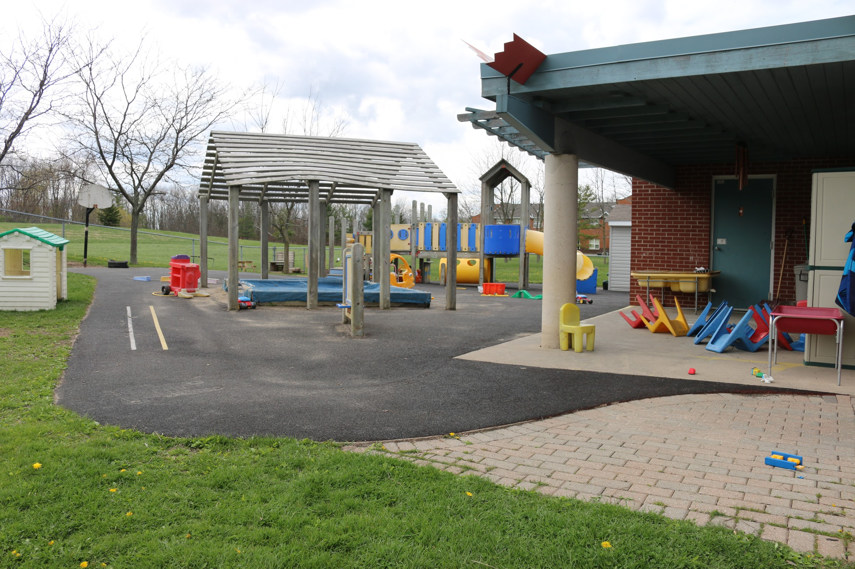
This ‘typical’ program consisted of a combination of activities that occurred both indoors and outdoors in a fenced playground area with prefabricated large play equipment (Figure 2).

Figure 2. Play yard of the ‘typical’ non-forest program

The Study

A 2-year mixed-method study examined the developmental and learning impacts of a nature-based program for 3- to 5-year-old children. In year 1 of the study (and the focus of this article), 8 children participated and attended a childcare center where a core component included participating in a forest school program two mornings a week from September to June. Multiple data collection tools were utilized throughout the inaugural year of the project, including surveys, interviews, participant observations, photo and video observations, and accelerometry measures. Although parents, educators, and children participated in the study, this article focuses on accelerometry measures and naturalistic observations of children’s play.

52 Harwood et al. – Exploring Young Children’s Play
______________________________________________________________________________

At three points throughout year 1 (fall, winter, and spring) the children were invited to wear an accelerometer (ActiGraph GT1M v6.6.3). ActiGraph accelerometers are commonly used in measures of physical activity, registering horizontal and vertical movement as well as the number of steps taken, and the devices have demonstrated consistency in measuring young children’s activity levels (Pate et al., 2004). Children’s physical activity levels were measured in one-minute epochs for two mornings in each of the three seasons (i.e., one morning in the forest school denoted as FS and one morning engaged in their ‘typical’ program, indicated as NFS or non-forest school). The monitors were attached to the children’s waist with an elastic strap and the recordings varied between 145-185 minutes (Table 1). The accelerometers were initialized to start collecting data at the same time each day (9 a.m. to noon).
Field observations accompanied all accelerometry measures and consisted of note taking, photos, and videos of all activities the children engaged in while in the woods. Children’s play activities were recorded and noted on a continuous basis both indoors and outdoors in a running record document. The primary investigator and a research assistant recorded all the qualitative data with one educator also contributing by noting the types of indoor play. The descriptive recording of children’s activities indoors and outdoors yielded approximately 18 hours of recorded data.
Statistical analysis of the accelerometry data was conducted with SPSS version 24.0 for Windows and included comparisons of mean activity levels between seasons, gender, and across forest school days to non-forest school days. Average group results were compared and then each participant’s results were examined by comparing their activity during each type of day and between seasons. There is little consensus on cut points for measuring children’s sedentary behavior (Youngwon, Lee, Peters, Gaesser, & Welk, 2014) and varied measures have been used for physical activity levels (Kuzik et al., 2015). Thus, we utilized Pate et al.’s (2004) oft-cited cut points and adapted 15-second epoch cut points to account for the 1-minute measures we used in the current study.

Table 1. Overall Totals for Moderate to Vigorous, Light Intensity, and Sedentary Activity Levels
 | CPM  Mean | Number of minutes reaching MVPA (% of time achieving) | Minutes at Light Physical Intensity (LPA) | Minutes at Sedentary Physical Activity (SPA)
Fall  FS  NFS | 1433  843 | 55 minutes (32%)  29 minutes (14%) | 110 mins (63%)  124 mins (62%) | 9 mins (5%)  48 mins (24%)
Winter  FS  NFS | 1397.00  803.46 | 57 minutes (33%)  13 minutes (9%) | 103 mins (60%)  106 mins (74%) | 12 mins (7%)  23 mins (17%)
Spring  FS  NFS | 1236.35  700.96 | 48 minutes (26%)  24 minutes (13%) | 126 mins (68%)  108 mins (58%) | 12 mins (6%)  54 mins (29%)

The International Journal of Holistic Early Learning and Development Vol. 4 2017 53
______________________________________________________________________________

Qualitative data was analyzed utilizing a theme-based coding system (Creswell, 2013), and informed by the activity type codes identified by Brown and colleagues (2006) (e.g., climb, crawl, dance, jump/skip, lie down, pull/push, rough and tumble). Theme-based analysis helped in examining the large qualitative data set for recurring patterns related to children’s play in both environments.

Quantitative Findings: Overall Activity Levels

Given the small sample size (n=8), simple descriptive statistical analysis was conducted. Overall, findings indicate that the mean counts per minute of activity were far greater for the children while participating in the forest program, regardless of seasonal variations (Table 1). LPA numbers rose slightly, on average, during fall and winter NFS days but decreased during the spring. SPA levels in the NFS environment were at least twice those of the FS in winter and close to five times higher in both the fall and spring. Thus, the two different environments had more of a profound impact on the levels of sedentary and MVPA than the light physical activity.
The differences in total step count movement between the two environments were also notable for each child. A concentration of much higher numbers for each participant’s step count was noted during each of the FS days in comparison to the respective NFS days. Also noted was a tendency for the children to be somewhat less active in the FS during the winter months compared to fall and spring; yet all rates of activity were still greater than the NFS context regardless of season (Figures 3 and 4).

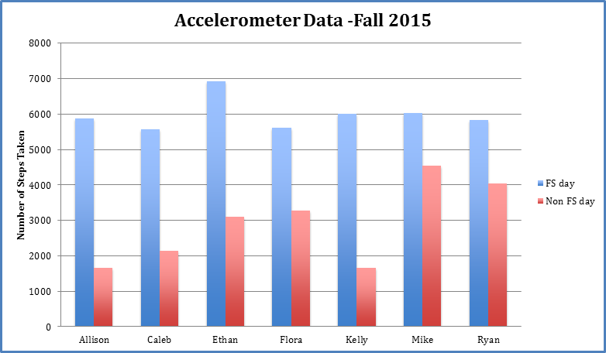
Figure 3. Accelerometer step count data – fall
Note: Data is not reported for Hannah due to an accelerometer device failure. All names are pseudonyms.

54 Harwood et al. – Exploring Young Children’s Play
______________________________________________________________________________

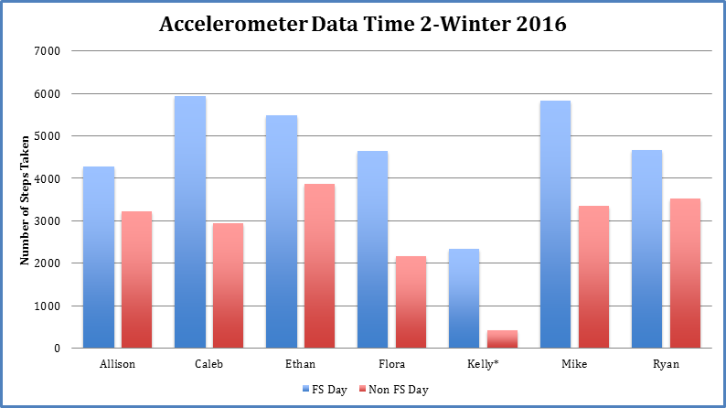
Figure 4. Accelerometer step count data – winter
Note: Kelly’s data reflects a recorded activity time of 85 minutes for FS and NFS days.

Individual Differences in Activity Levels

The children’s activity levels (MVPA) were more than double the rate of physical activity exhibited during their ‘typical’ day. This pattern of MVPA in the forest was consistent across fall, winter, and spring. The average intensity of movement was at its highest in the fall (forest day) and lowest in the spring (non-forest day). Moreover, children who were naturally more sedentary overall (irrespective of environments), similarly benefitted from the forest environment with MVPA levels that were more than two times higher than those recorded in the non-forest environment. For example, Allison was active (MVPA) 25% of the time on the fall FS day but less than 2% of the time during the NFS day (Figure 5). More active children tended to be physically active regardless of the environment, yet an increased MVPA level in the FS setting was evident. For example, in the fall season Ryan was active 48% of the time at the FS and only 29% of the time on the NFS day (Figure 5). Overall, children’s total activity per day in the forest averaged 51 minutes of MVPA whereas 22 minutes per day of MVPA was experienced in the ‘typical’ program. Thus, irrespective of a child’s tendency to be active or not as active, all participants were more intensively active during FS days.

The International Journal of Holistic Early Learning and Development Vol. 4 2017 55
______________________________________________________________________________
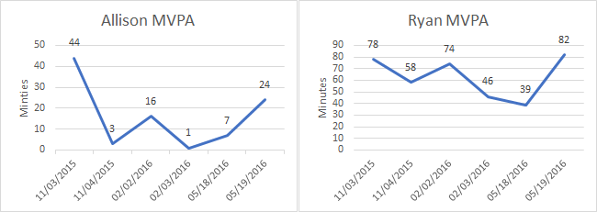

Figure 5. Individual MVPA differences for Allison and Ryan

FS dates: 11/03, 02/02, and 05/19

Gender Differences

There was no statistically significant difference between genders but a simple observation of step counts per minute (CPM) demonstrated that boys were more moderately and vigorously active overall. The gap in activity between genders was most noticeable during the fall season in both forest and non-forest school settings. Interestingly, over time the gap between the genders narrowed, especially in the forest environment. The CPM variance between males and females in the forest environment steadily decreased from 445.25 (fall) to 134.67 (spring) (Figure 6). In the NFS setting the change was less prominent, decreasing from 461.25 CPM (fall) to 341.67 CPM (spring). Thus, the gap between boys and girls remained noticeably wider. Given the small number of participants the results here are not conclusive, yet they do provoke interest in future research on the gender impacts of a forest school model.

56 Harwood et al. – Exploring Young Children’s Play
______________________________________________________________________________

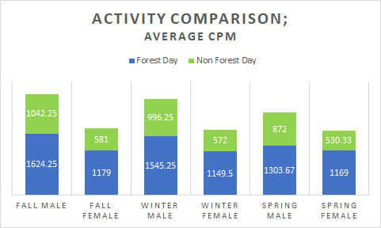

Figure 6. Comparison of total average step CPM by males and females per season

Qualitative Findings

The children’s physical activity levels appeared to be impacted by the space and the types and qualities of the play in the forest school program. The specific themes that emerged are discussed in terms of the distinct affordances and loose parts in the forest, and the diverse types of active play enacted in the forest environment.

Affordances and Loose Parts

The space in the forest was considerably larger than any of the spaces the children encountered within the typical program. The vastness of the space tended to invite opportunities for greater freedom and self-directed, unstructured activities (e.g., following deer trails deeper into the woods, running at full speed). Additionally, the environment in the forest offered several unique potential affordances that were not evidenced with the typical program. For example, trees were readily available in the forest for climbing and balancing. Although similar equipment was noted within the play yard of the typical program, climbing trees tended to include whole body movements and require higher levels of physical skill (e.g., pulling oneself up into a tree versus using a ladder to climb a slide apparatus). In addition to trees, the forest had large boulders for climbing as well as greater variation in the sloped and uneven terrains the children encountered (Figure 7).
The potential and realized affordances in the forest also varied from the typical day. The children directed much of their own play in the forest, even choosing which routes to travel to the site, as well as establishing boundaries for the site and contributing ideas for play (e.g., building a den, tree swing, or teeter totter). Climbing, balancing, teetering, construction, moving logs and boulders, and so on were all supported within the forest area. Unlike the loose parts in the typical program (predominantly prefabricated, plastic, and purposefully manufactured for
The International Journal of Holistic Early Learning and Development Vol. 4 2017 57
______________________________________________________________________________

childcare programs), the forest contained natural materials that varied in size, density, weight, and height. Children were readily observed moving and carrying large logs and boulders as well as manipulating small objects in the forest (e.g., nuts, sticks, pebbles, and rocks).
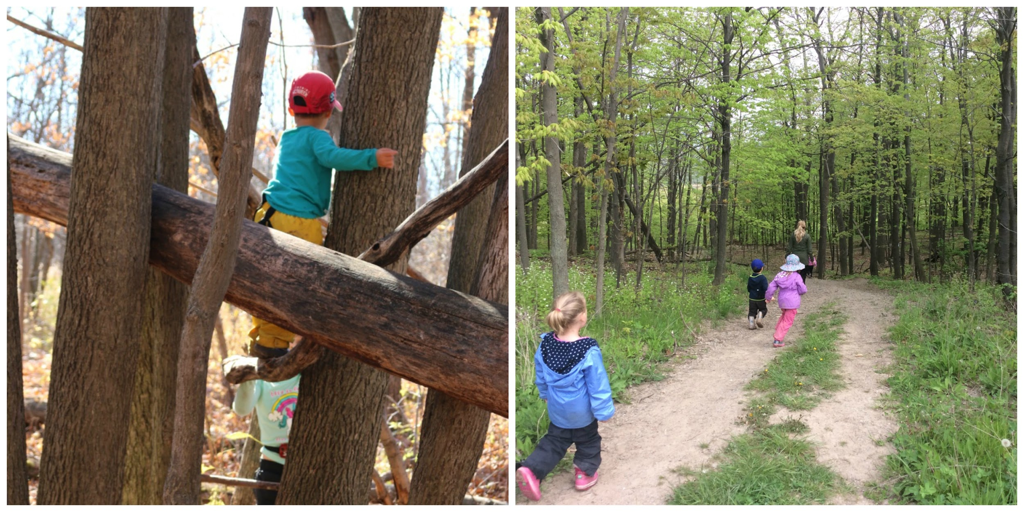

Figure 7. Climbing and terrain affordances of the forest school program

Types of Play Activities in the Forest

Play in the forest school program appeared to contribute uniquely to the vigorous levels of activity. Unlike the typical program, play within the forest was primarily unstructured and self-directed. Many of the activity codes considered by Brown and colleagues (2006) (e.g., “climb, crawl, dance, jump/skip, lie down, pull/push, rough and tumble, ride, rock/roll, run, sit/squat, stand, swing, throw, walk, other”) (p. 169) were evident in both environments. However, play in the forest was distinct in the specific provision of risk taking and greater diversity of play opportunities, including whole body play (e.g., climbing trees, building forts), rough and tumble play, swinging, throwing, and walking (i.e., the forest site was a half-kilometer walk). Some of these activities were not observed or permitted within the typical program (e.g., climbing trees, rough and tumble, games of chase, swinging, and throwing).
Rough and tumble play, games of chase and games with rules (e.g., hide and seek, superhero type of play) were popular in the forest and observed regularly. Specifically, rough and tumble play typically occurred en route to the forest school site as the children crossed a large open field. The play itself involved the whole group of children running, chasing, and ‘play fighting’ or wrestling; the play was always themed around ‘good versus bad’ and usually involved children in varied superhero roles. The play was closely monitored by the educators; however, the children largely directed this play and disputes were settled independent of the educators.
The self-directed and unstructured nature of the play in the forest, combined with the openness of materials, meant children were inventive with their play. The play in the forest differed significantly from the play in the typical program. The forest area was much more complex in terms of the terrain, vegetation, space, and the complexity of affordances and loose
58 Harwood et al. – Exploring Young Children’s Play
______________________________________________________________________________

parts. Specific forms of play were only evident in the forest area with some forms linked to the landscape elements (e.g., trees). Clearly, the present study hints at the possible role of a forest school in fostering and promoting physical movement.

Considerations and Discussion

The small number of participants limits the definitive conclusions that can be made about the specific effects of environments on children’s levels of activity. Additionally, the study lacked a focus on the educator and his/her role in promoting children’s physical activity. But like others (Kwon et al., 2015), we hypothesize that the educator may hold a crucial role in fostering an environment for active play as well as directly impacting physical activity levels through intentionally structured activities. A larger scale study with a focus on multiple factors (e.g., educators, weather, season, time of week, child-environment affordances) would yield more accurate insights regarding the ways in which environments impact (positively or negatively) the physical activity of young children.
Here, the consistency of the results does suggest that young children can meet or exceed recommended activity levels within a program such as a forest school. Additionally, our study does raise some important questions regarding gender and the potential of a forest school environment to perhaps narrow gaps in physical activity levels between boys and girls. Potentially, specific factors such as weather, affordances, and loose parts may impact children’s physicality in very different ways. Is the forest school setting more of a neutral space, less prescribed and structured, and therefore giving rise to more equalized opportunities for active play? Or does the amount of space and diversity within it afford greater and more equalized levels of activity? Perhaps, as children become accustomed to the forest space they become less active or interested in forms of play that are less active. More research is needed to examine these nuances within various environments.
The perception that young children are relatively active seems somewhat misguided given the variance found between the FS and NFS contexts. In this study, the children were two times more active in the forest environment, irrespective of the season. Moreover, the forest environment clearly impacted and helped to minimize sedentary behavior, an important health benefit. Unique to the forest school, the environment here acted as a mechanism to narrow the gap between the boys’ and girls’ activity levels. The affordances and loose parts of the forest area also contributed uniquely to the children’s activity levels. Weather may have also had a direct impact on active play levels. Although seasonal variances were quite minimal for both FS and NFS days (8 °C - fall, 3 °C -winter, 15 °C - spring), conditions such as rain, snow, ice, and mud kept children indoors (or on a walk) on non-forest school days. Whereas on forest school days, these same conditions did not preclude trips to the forest (Figure 8).

The International Journal of Holistic Early Learning and Development Vol. 4 2017 59
______________________________________________________________________________
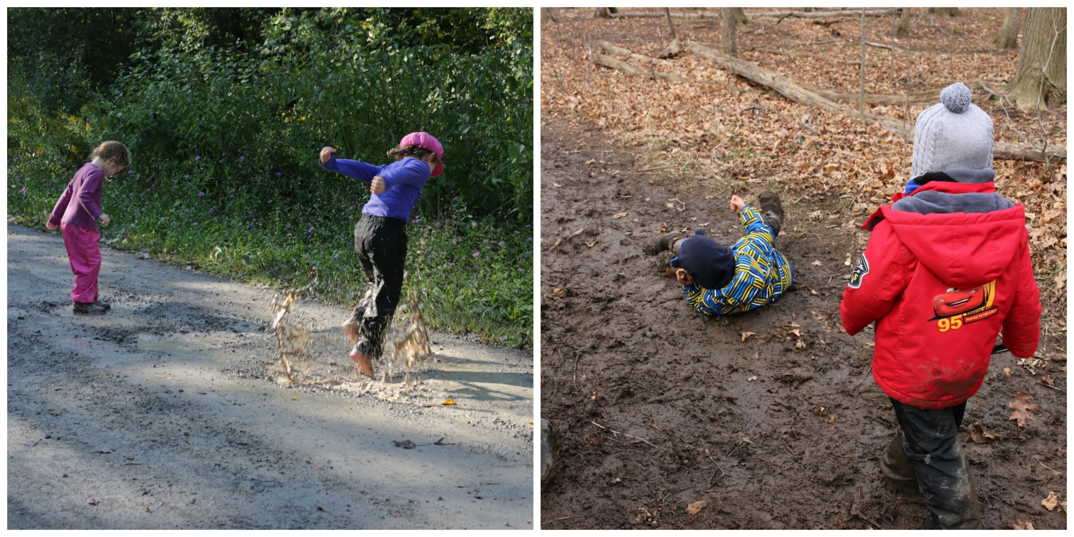

Figure 8. Mud play was only afforded in the forest school program

Perhaps activity happened more spontaneously in the forest given the largeness of the area, diversity of opportunities, and environmental complexity (Fjørtoft, 2000). The findings of this study revealed that the most vigorous play happened in the forest, and results reaffirm that “natural environments offer potential qualities that are a catalyst for physical activity” (Bjørgen, 2016, p. 1). Types of play that encourage physical activity need to be provided for within childcare programs. Future research should examine children’s activity levels with the multiple constructs that appear influential, such as environments, play activities, affordances and loose parts, as well as the educator’s role. Educators themselves should also reflect on the range of play and vigorous activities that are afforded by more ‘natural’ spaces, and making use of city parks, open fields, beaches, gardens, and so on could have positive impacts for children.
This small-scale study provides insight into reconsidering the ways in which all childcare environments are conceived and constructed. What do the specific environments afford and which play opportunities are supported that foster and promote physical movement? Taken-for-granted assumptions of the active child must be reconsidered and childcare environments and educators are invited and challenged to find ways in which to incorporate play within a natural (forest) environment as an avenue of fostering higher activity levels for children.

60 Harwood et al. – Exploring Young Children’s Play
______________________________________________________________________________

References

