

Instructions for authors and further details:

http://ijheld.lakeheadu.ca

Kindergarten Landscapes

Multiple Contributors

Published online: November 1, 2017

Edition period: Volume 4, 2017

PLEASE SCROLL DOWN

The International Journal of Holistic Early Learning and Development Vol. 4 2017 63
______________________________________________________________________________

Kindergarten Landscapes

Multiple Contributors

The following Full Day Kindergarten environments were designed by 1st year students in the Bachelor of Education program at Lakehead University’s Faculty of Education, Orillia Campus, Ontario, Canada.

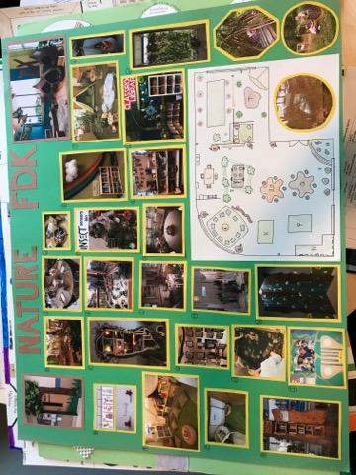
Figure 1. Katie Garagan & Carmen Vella

64 Multiple Contributors – Kindergarten Landscapes
______________________________________________________________________________

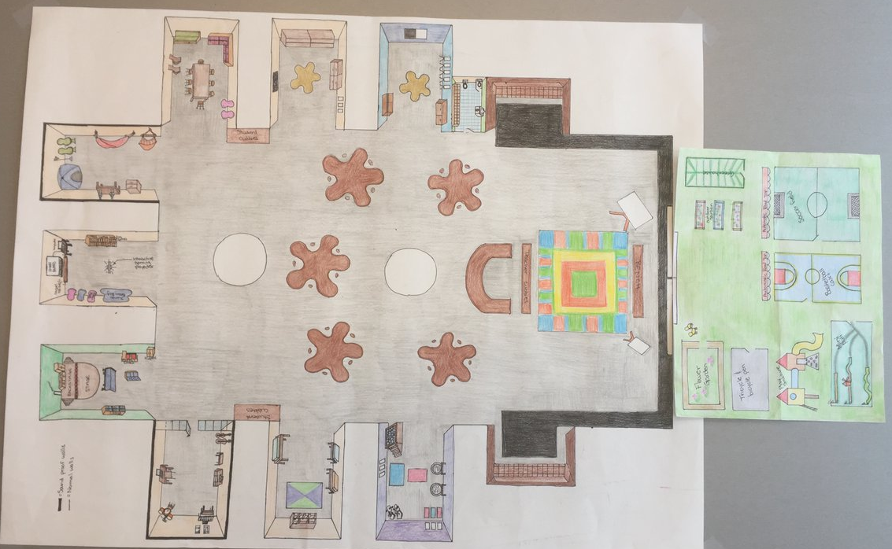
Figure 2. Rebecca Alize Minty & Catherine Kuo

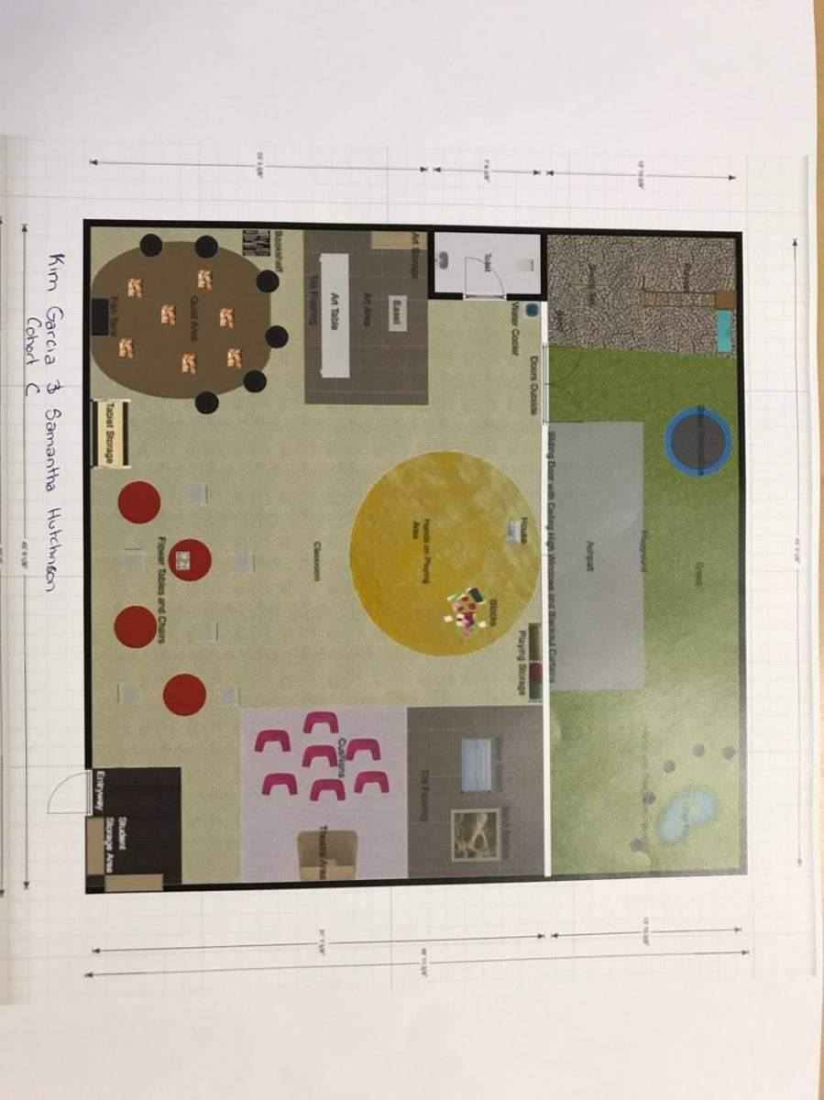
Figure 3. Kim Garcia & Samantha Hutchinson
The International Journal of Holistic Early Learning and Development Vol. 4 2017 65
______________________________________________________________________________

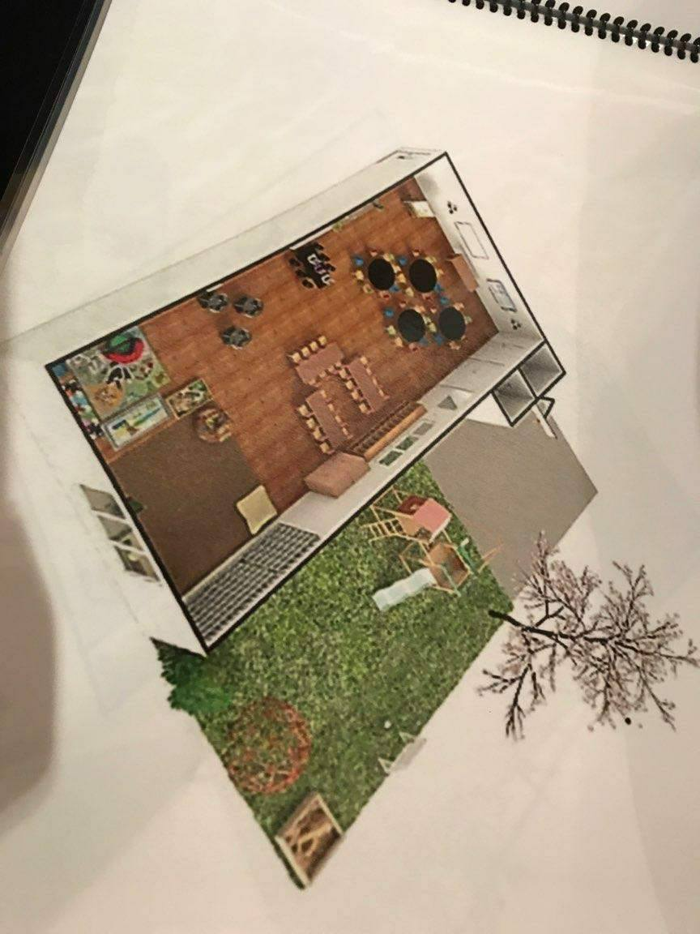
Figure 4. Monica Wood & Michele Ditta

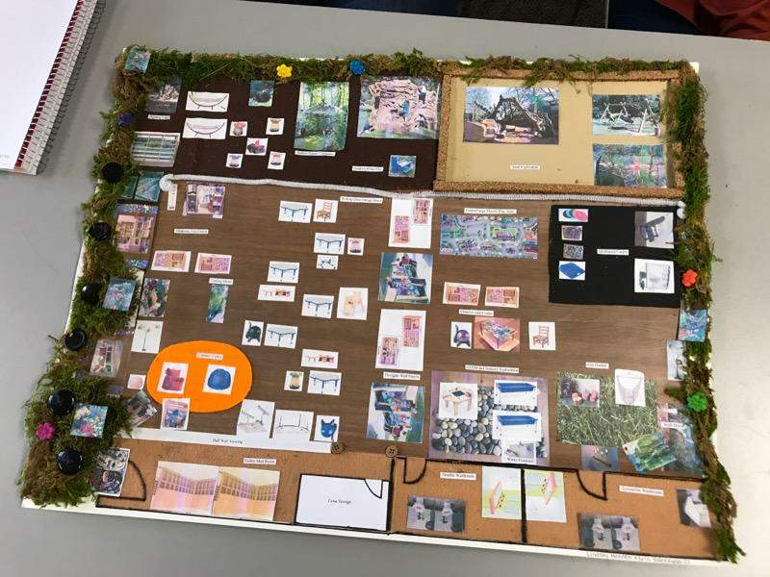
Figure 5. Lindsay Mennen & Erin Valenzuela
66 Multiple Contributors – Kindergarten Landscapes
______________________________________________________________________________

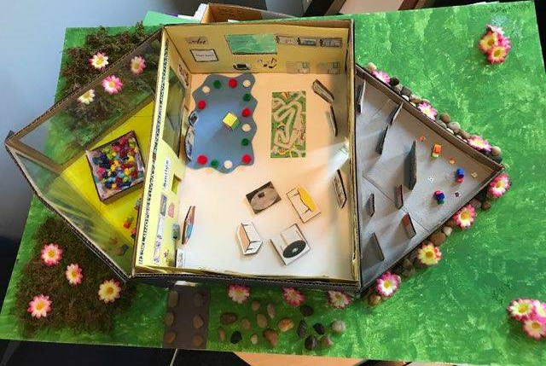
Figure 6. Anita Borges & Marie Riad

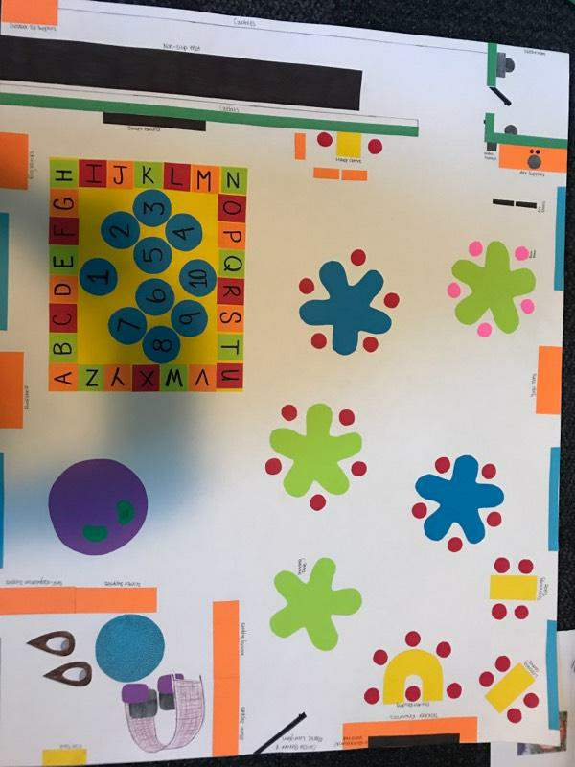
Figure 7. Carissa Berner & Marlie Lavrijsen

The International Journal of Holistic Early Learning and Development Vol. 4 2017 67
______________________________________________________________________________

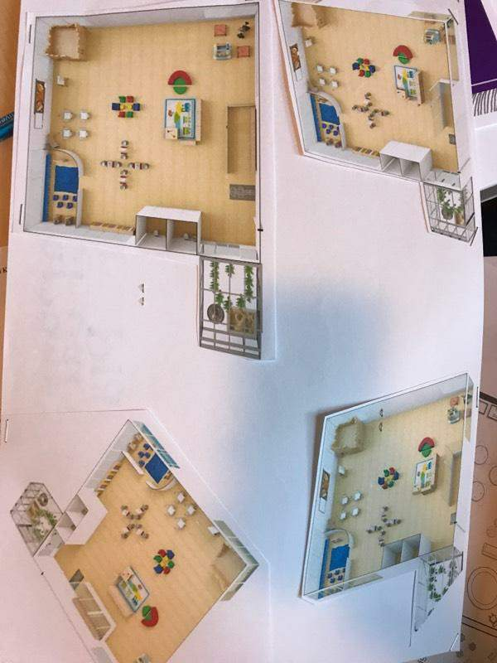
Figure 8. Andre St. Pierre & Joshua Gomes

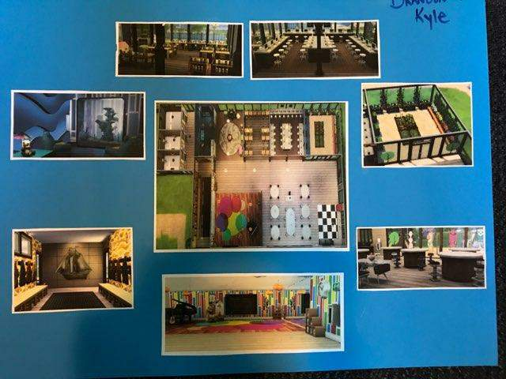
Figure 9: Kyle Frederickson & Brandon Blair

68 Multiple Contributors – Kindergarten Landscapes
______________________________________________________________________________

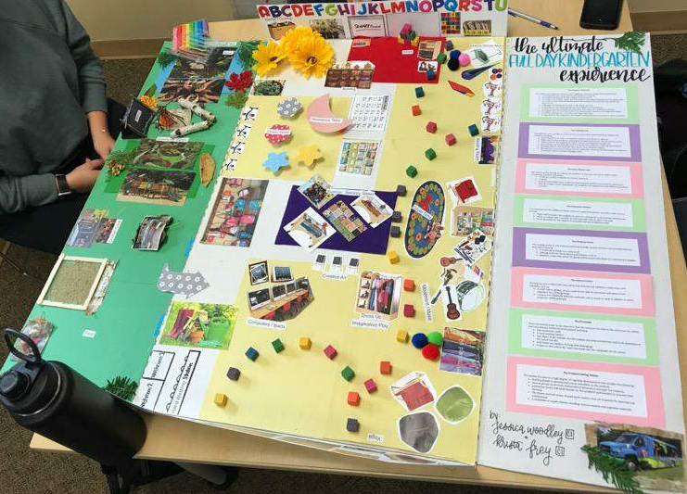
Figure 10. Jessica Woodley & Krista Frey

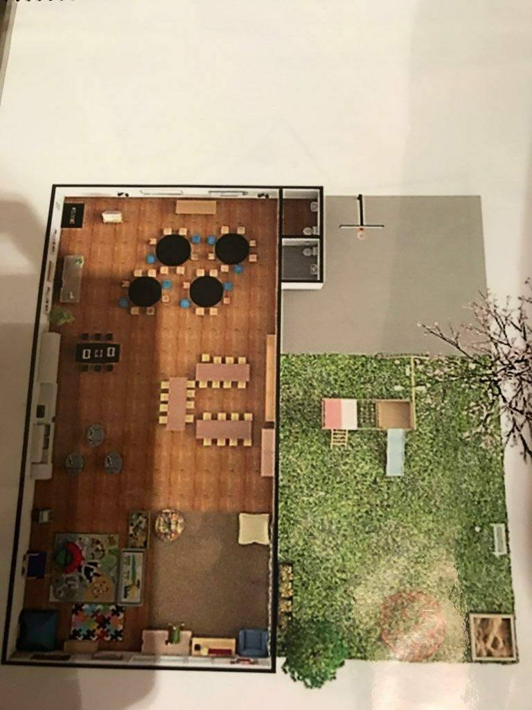
Figure 11. Monica Wood & Michele Ditta

The International Journal of Holistic Early Learning and Development Vol. 4 2017 69
______________________________________________________________________________

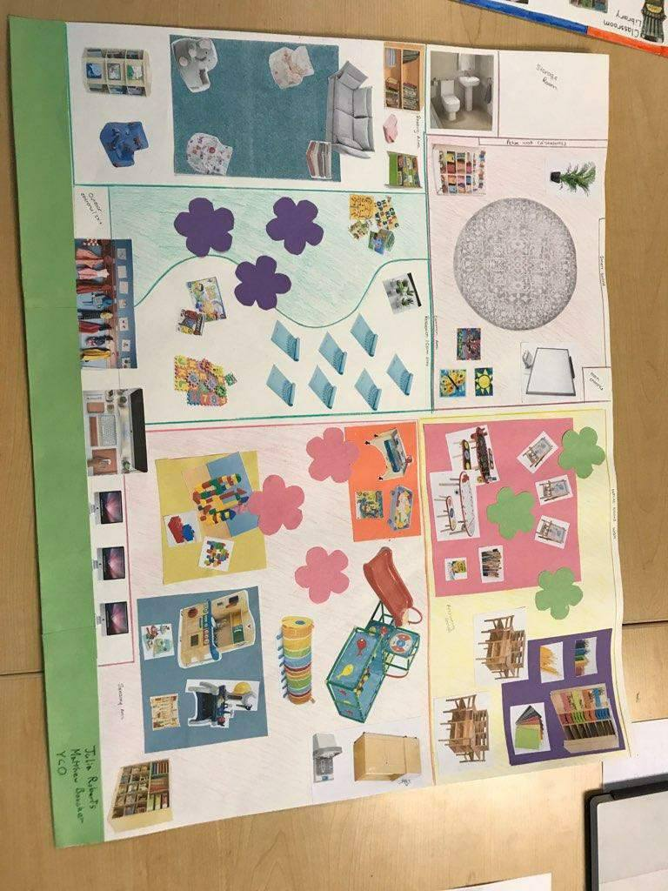
Figure 12. Julia Richards & Matthew Boucher (YCO)

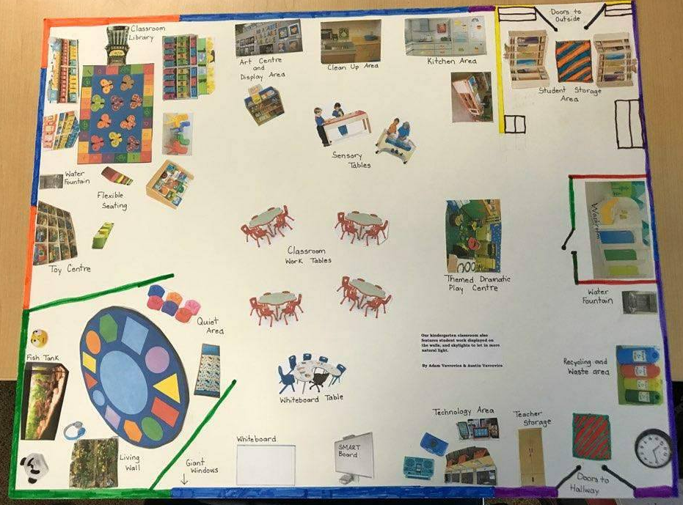
Figures 13 & 14. Adam Vavrovics & Austin Vavrovics

70 Multiple Contributors – Kindergarten Landscapes
______________________________________________________________________________

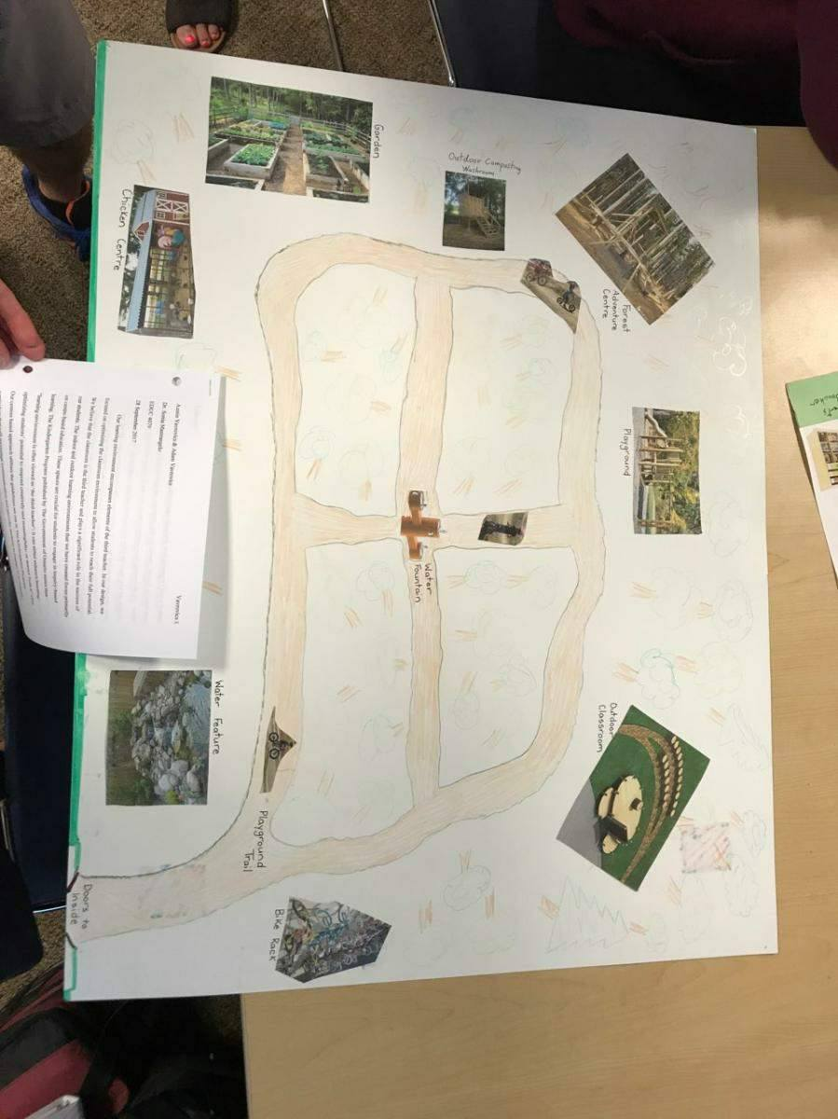
Figure 14.

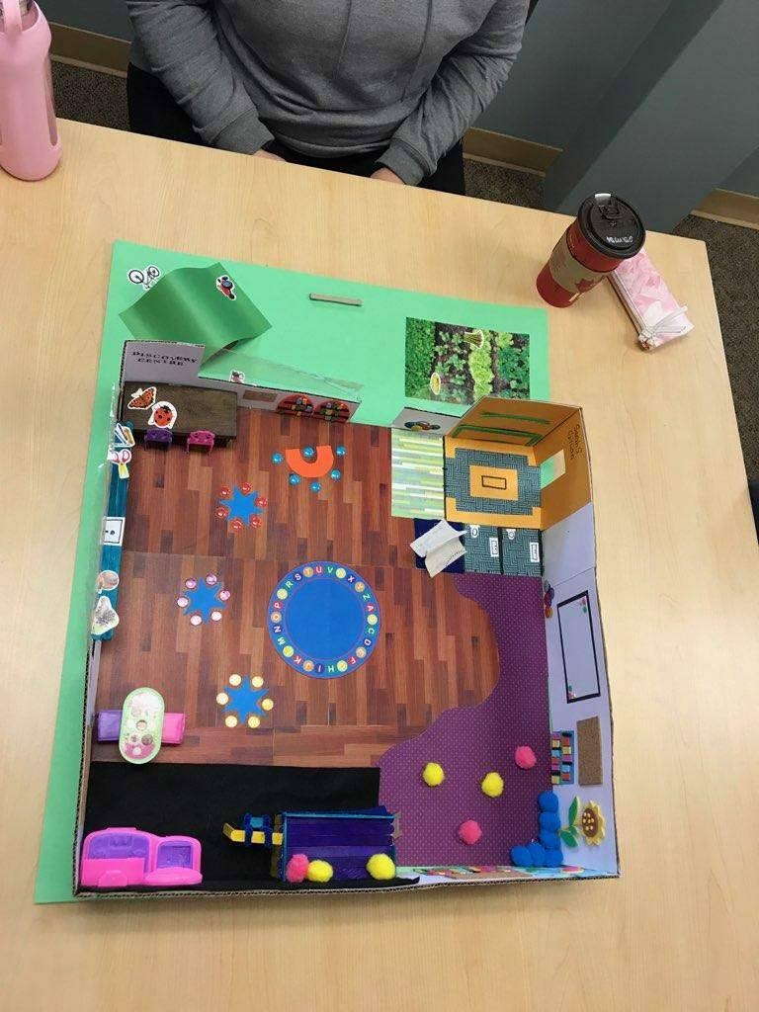
Figure 15. Sarah Seaidoun & Gillian Harries

The International Journal of Holistic Early Learning and Development Vol. 4 2017 71
______________________________________________________________________________

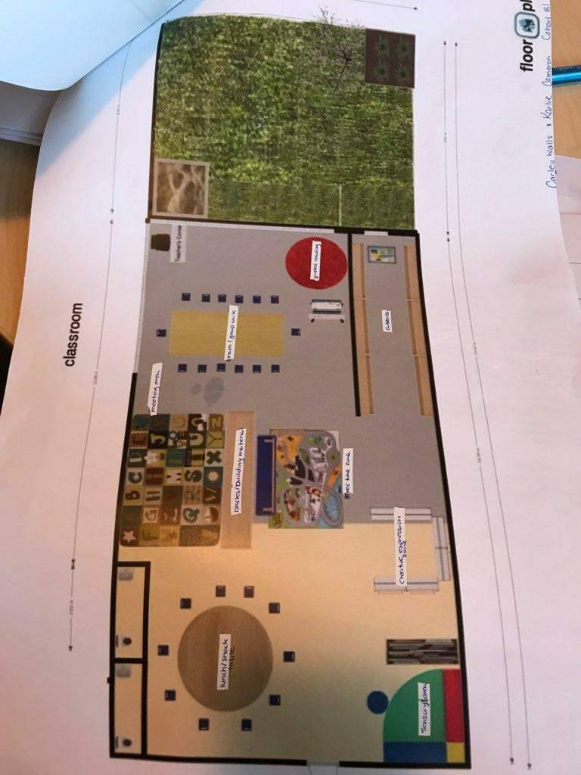
Figure 16. Karlie Cameron & Carley Walls

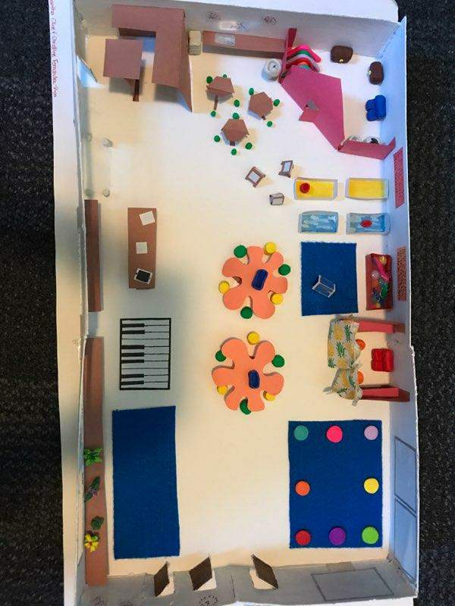
Figure 17. Christine Fernandez & Samantha Cline

72 Multiple Contributors – Kindergarten Landscapes
______________________________________________________________________________

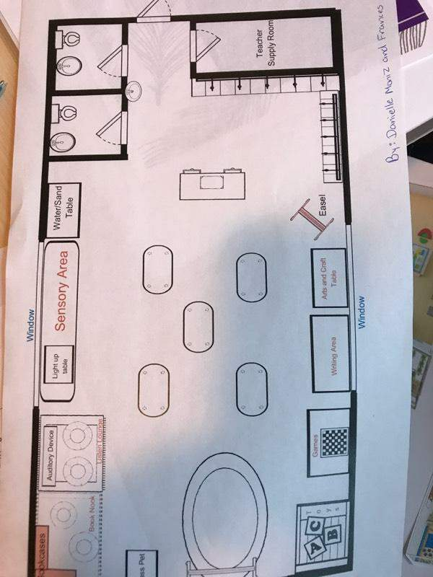
Figure 18. Danielle Moniz & Frances Aiello

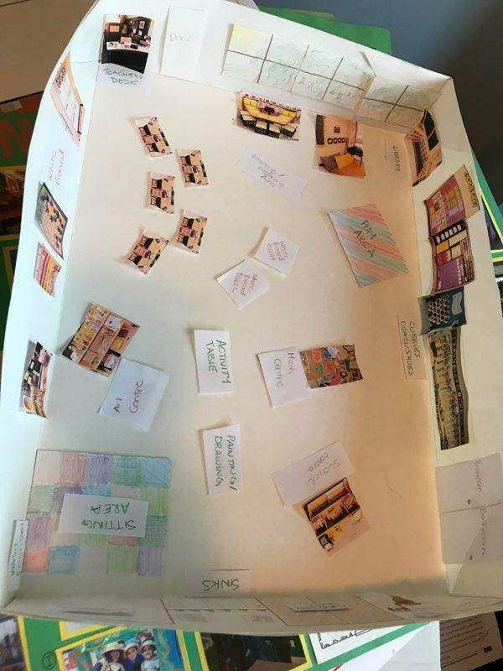
Figure 19. Jessie Bain & Jaimie Bain

The International Journal of Holistic Early Learning and Development Vol. 4 2017 73
______________________________________________________________________________

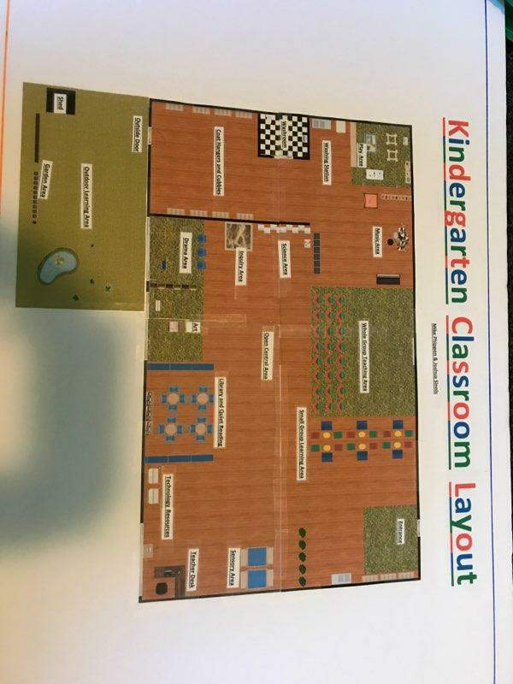
Figure 20. Mike Phippen & Joshua Sinnis

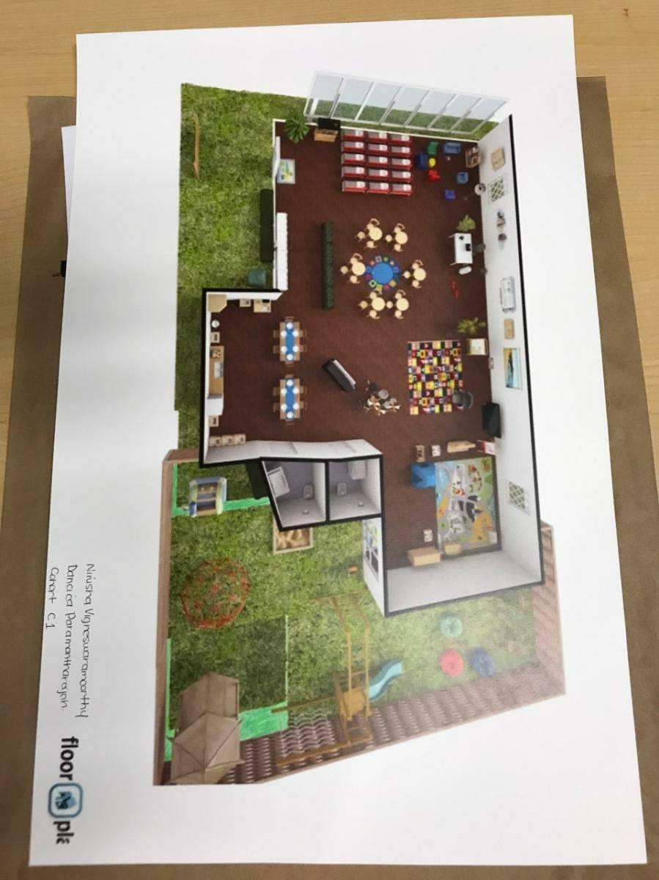
Figure 21. Nirusha Vigneswaramoorthy & Dancica Paramanantharajah
74 Multiple Contributors – Kindergarten Landscapes
______________________________________________________________________________

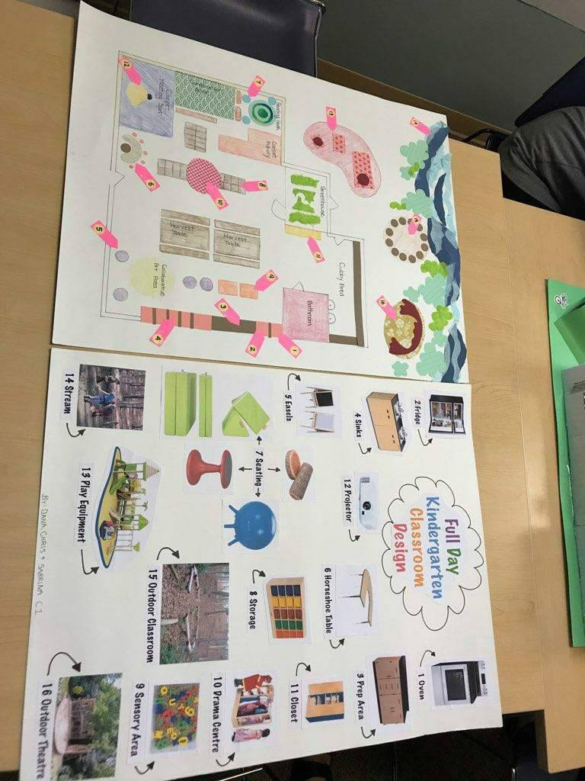
Figure 22. Chris Taylor, Dana Egan, & Sabrina Parrish

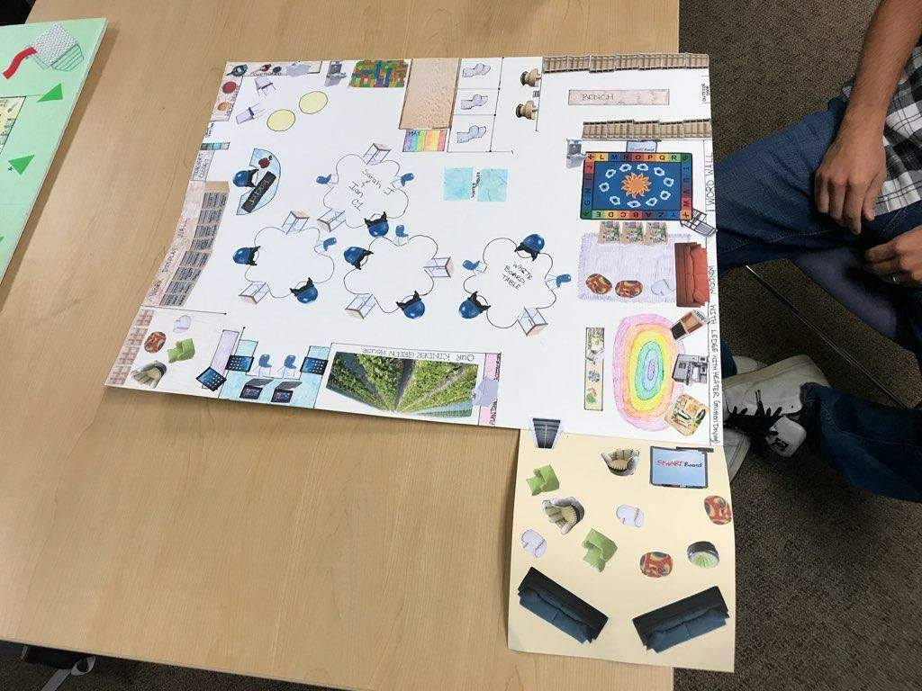
Figure 23. Ian Cockburn & Sarah Jargiello
The International Journal of Holistic Early Learning and Development Vol. 4 2017 75
______________________________________________________________________________

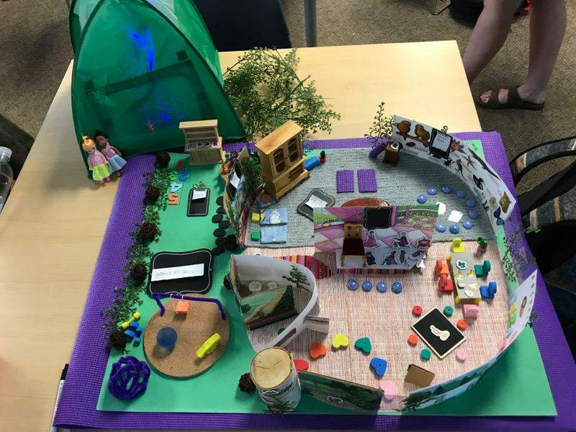
Figure 24. Victoria Houle & Samantha Stiavnicky

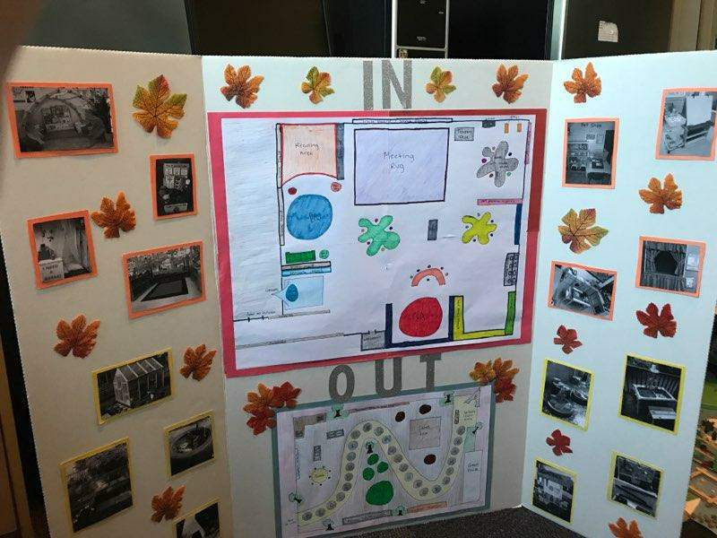
Figure 25. Laura Harmer & Harman Rakkar

76 Multiple Contributors – Kindergarten Landscapes
______________________________________________________________________________

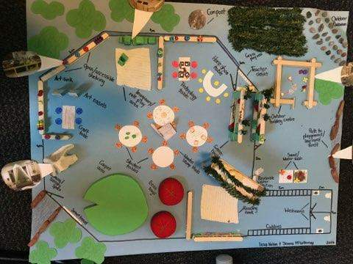
Figure 26. Jenna McGillivray & Izzy Nolan

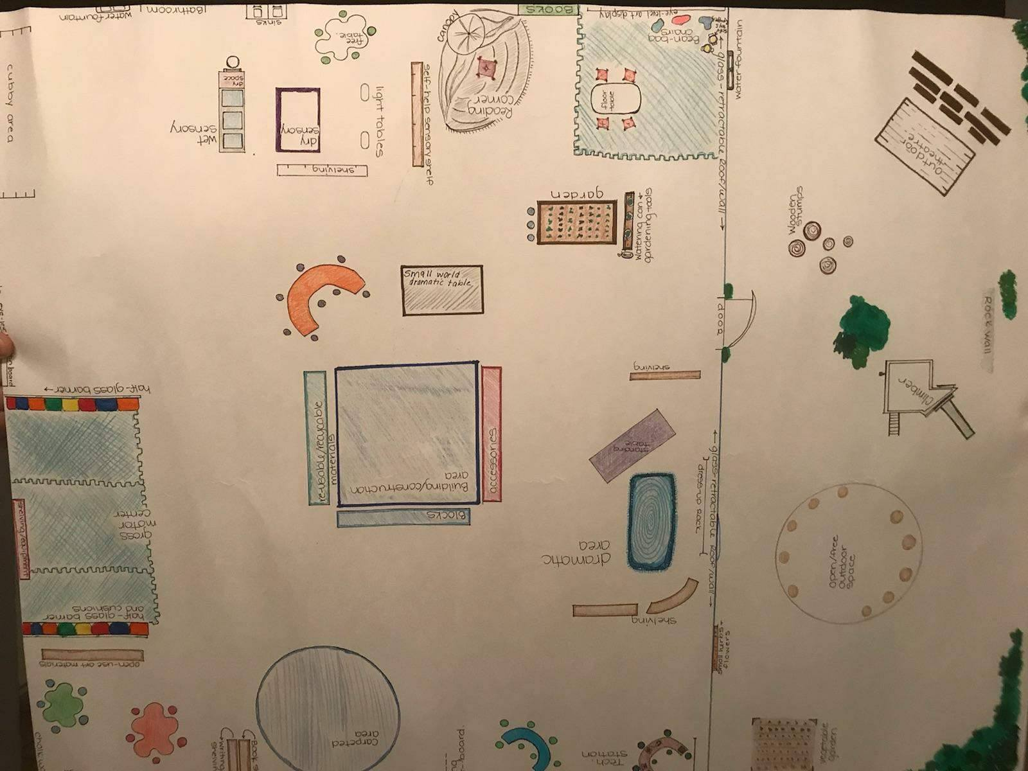
Figure 27. Amiteshwar Mangat & Romina Alati

The International Journal of Holistic Early Learning and Development Vol. 4 2017 77
______________________________________________________________________________

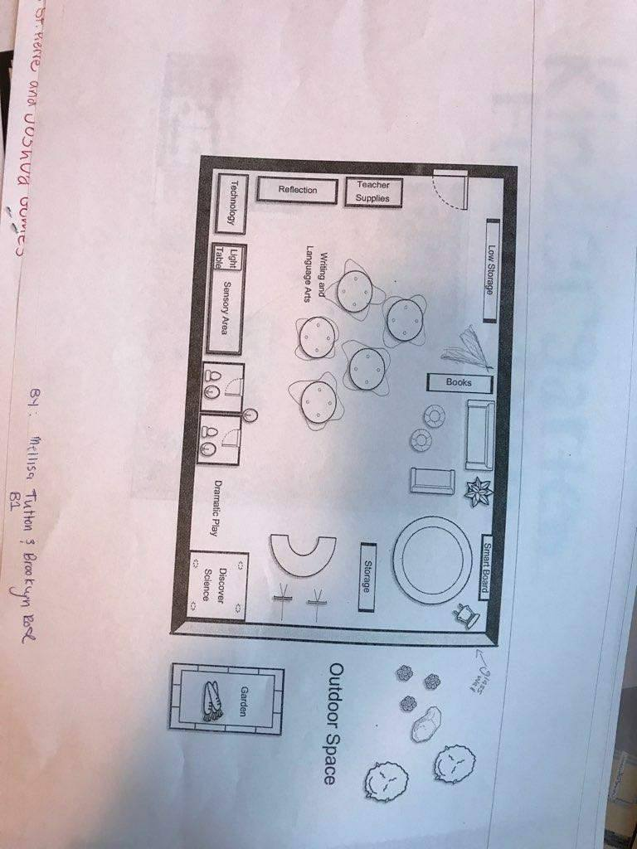
Figure 28. Melissa Tutton & Brooklyn Rose

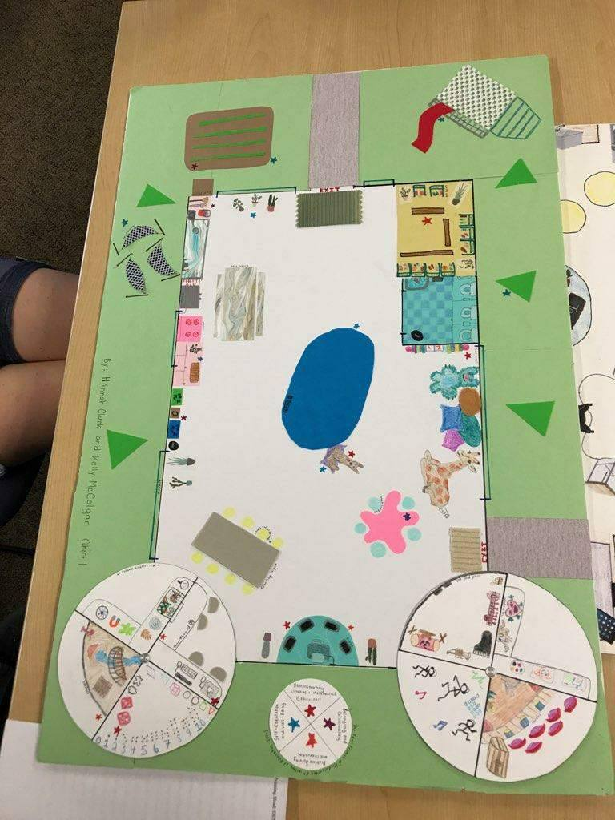
Figure 29. Hannah Clark & Kelly McColgan

78 Multiple Contributors – Kindergarten Landscapes
______________________________________________________________________________

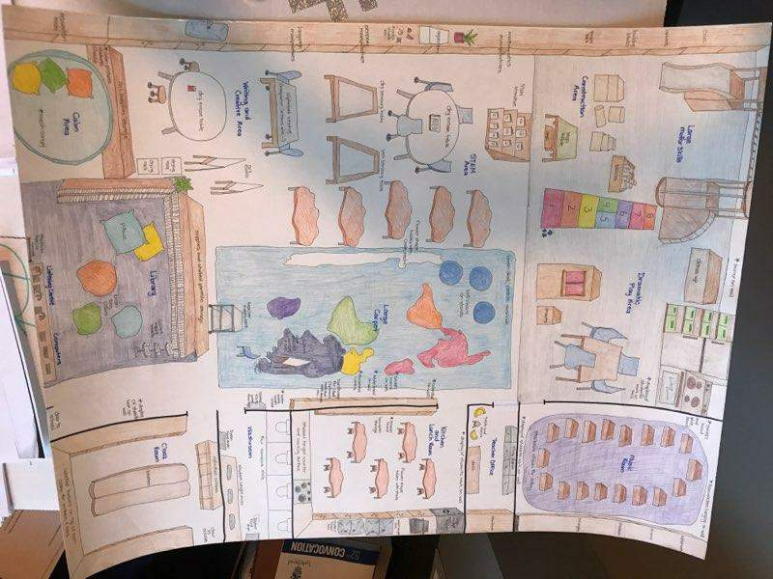
Figure 30. Kelly Banks & Crystal Jones

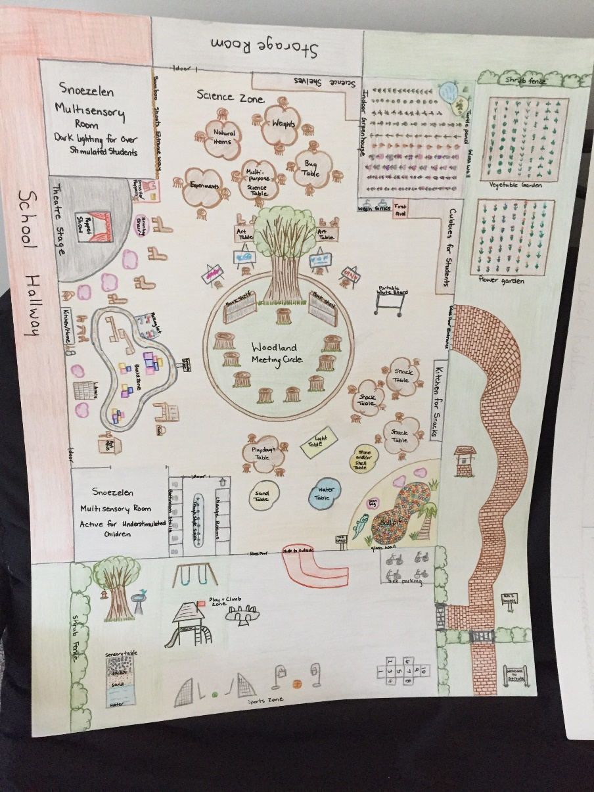
Figure 31. Kristina Hinves & Tim Wong
The International Journal of Holistic Early Learning and Development Vol. 4 2017 79
______________________________________________________________________________

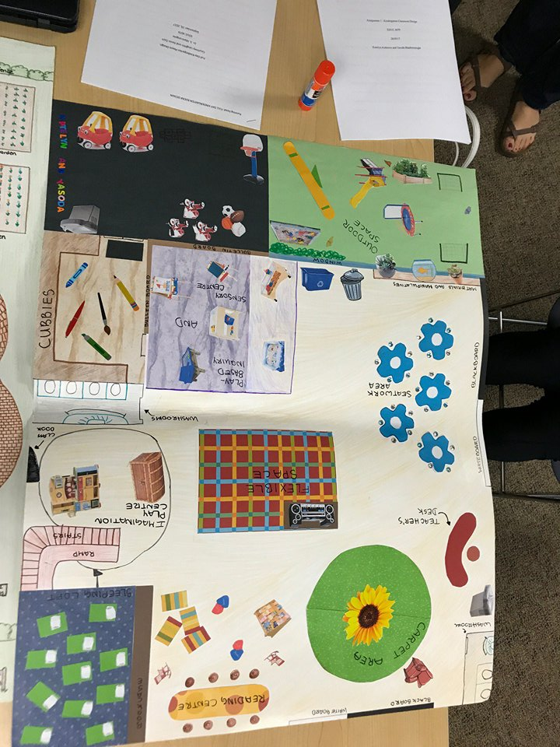
Figure 32. Katelyn Anderson & Yasoda Bhadreenaught

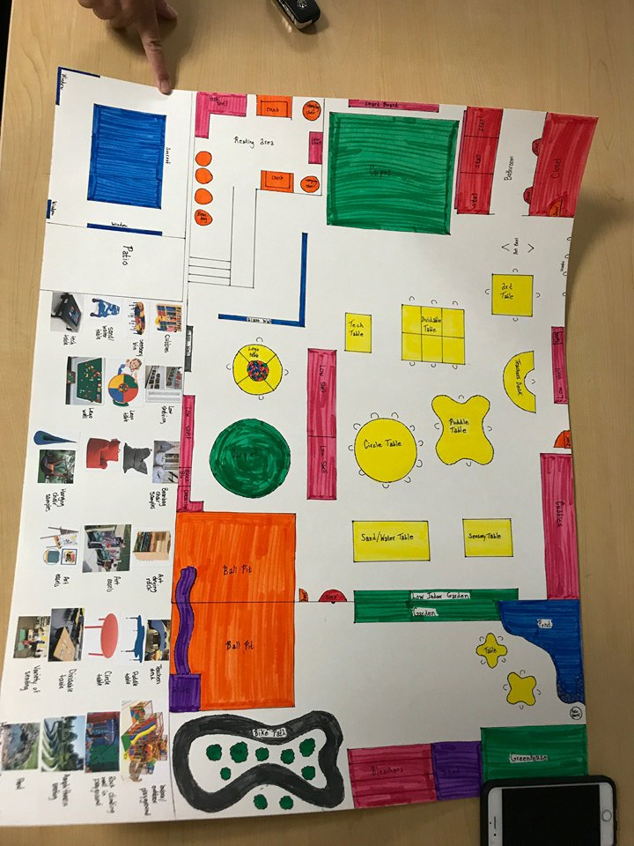
Figure 33. Kevin Zych & Courtney Laughlin

